

HUMAN BIOLOGY

UNIT 3 and 4 Semester Two 2019

Marking Key

Marking keys outline the expectations of examination responses. They help to ensure a consistent interpretation of the criteria that guide the awarding of marks.

© Copyright Academic Associates 2019.

|  |  |
| --- | --- |
| Section One: Multiple–choice | 30% (30 Marks) |

_____________________________________________________________________________

|  |  |
| --- | --- |
| **Question** | **Answer** |
| 1 | D |
| 2 | A |
| 3 | B |
| 4 | C |
| 5 | B |
| 6 | A |
| 7 | A |
| 8 | C |
| 9 | D |
| 10 | C |
| 11 | B |
| 12 | B |
| 13 | B |
| 14 | D |
| 15 | A |
| 16 | B |
| 17 | C |
| 18 | D |
| 19 | B |
| 20 | C |
| 21 | C |
| 22 | A |
| 23 | D |
| 24 | D |
| 25 | C |
| 26 | B |
| 27 | C |
| 28 | D |
| 29 | D |
| 30 | B |

|  |  |
| --- | --- |
| **Section Two: Short answer** | **50% (100 Marks)** |

|  |  |
| --- | --- |
| **Question 31** | **(7 marks)** |

Parts (a) and (b) refer to the image of tools shown below.

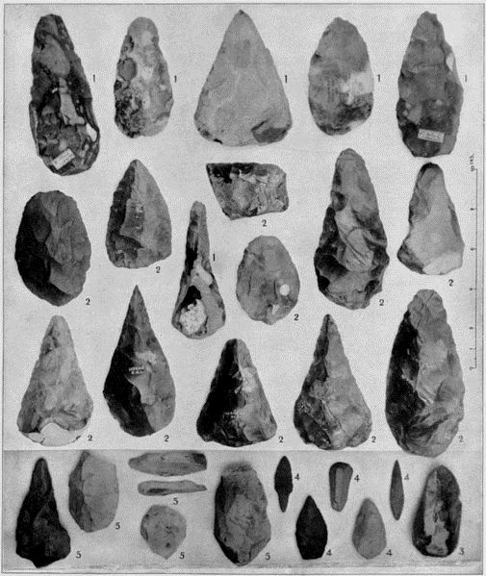

1. Name the species of hominins associated with these tools. (1 mark)

|  |  |
| --- | --- |
| **Description** | **Marks** |
| *Homo erectus* | 1 |
| **Total** | **1** |

1. Name and describe the tool culture of this species, explaining how the tools that they produced contributed to their lifestyle. (6 marks)

|  |  |
| --- | --- |
| **Description** | **Marks** |
| Acheulian tools | 1 |
| Any **five** of:   * Hand axe stone tools * Finely made, chip marks/flakes on both sides * Used for scraping and cutting * First true hunters and said they used cooperative hunting * Able to make and control fire * “Home base” activities for the manufacture of tools/cutting up carcasses | 1-5 |
| **Total** | **6** |

|  |  |
| --- | --- |
| **Question 32** | **(13 marks)** |

Measles is a very contagious viral illness that causes a skin rash and fever. It can potentially cause serious, sometimes fatal, complications including pneumonia.

Measles is rare in Australia because of the widespread use of the measles vaccine. Vaccination is important because people travelling from overseas can carry the virus. The incidence of cases of measles in Australia has increased in the last 3 years, causing concern for health authorities.

1. Explain the body’s cell mediated response to vaccines, to enable people who are exposed to diseases such as measles to remain unaffected. (5 marks)

|  |  |
| --- | --- |
| **Description** | **Marks** |
| Antigen from vaccine is engulfed by macrophage/B-Cell and displays it on its surface | 1 |
| Specific T Helper Cells are sensitized, enlarge and divide into clones | 1 |
| Memory T-Cells recognise the antigen for a rapid secondary exposure | 1 |
| Killer T-Cells secrete substances to destroy the antigen before the person becomes ill. | 1 |
| Helper T-Cells attract macrophages to the site of the antigen  **OR** Helper T-Cells intensify phagocytosis | 1 |
| **Total** | **5** |

Must say all.

1. Explain **two** possible reasons for the sudden increase in the incidence of measles cases in Australia. (2 marks)

|  |  |
| --- | --- |
| **Description** | **Marks** |
| Parents/people choosing not to vaccinate their children/be vaccinated | 1 |
| People travelling from countries where measles is more common bring the virus into the country and infect Australians in the community | 1 |
| **Total** | **2** |

Take the first two.

1. Describe **two** ethical concerns about the use of vaccines. (2 marks)

|  |  |
| --- | --- |
| **Description** | **Marks** |
| Any **two** of:   * Treatment of animals as some vaccines require host tissue to grow * Use of human tissue/source of human tissue * Unethical testing of vaccines in groups of people who are not fully informed * Testing of vaccines on animals/animal cruelty | 1-2 |
| **Total** | **2** |
| **Note:** Do not award marks for religion (cultural) | |

Take the first two

A student received the vaccine for measles and then three months later was exposed to the measles pathogen.

1. On the axes below, draw and clearly label the antibody response for a student when they received the vaccine and when they were subsequently exposed to the pathogen. (4 marks)

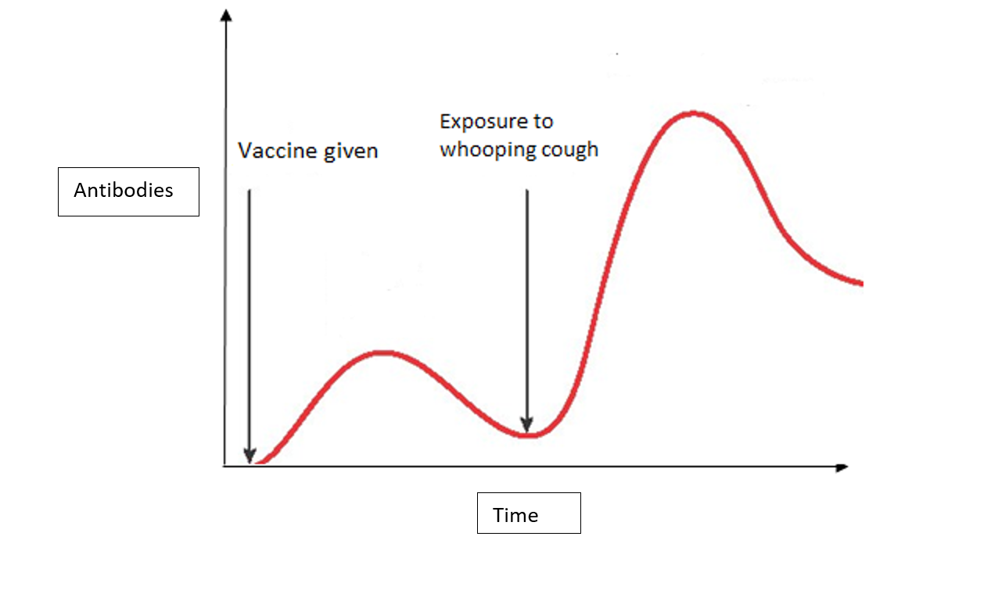

|  |  |
| --- | --- |
| **Description** | **Mark** |
| Accurate curve for primary response | 1 |
| Accurate curve for secondary response | 1 |
| Accurate label for vaccine being received | 1 |
| Accurate label for exposure to whooping cough | 1 |
| **Total** | **4** |

|  |  |
| --- | --- |
| **Question 33** | **(12 marks)** |

Some fossils of Aboriginal people were found in Victoria, very close to a river. The method used to date the remains was Carbon-14 dating.

1. Explain the process of Carbon-14 dating. Include in your response, how to calculate the age of the specimen using this technique. (5 marks)

|  |  |
| --- | --- |
| **Description** | **Marks** |
| Any **three** of:   * Plants absorb C14 during photosynthesis * C14 is passed to animals through the food chain * Atmospheric ratio of C:14 to C:12 is 1 to 1 trillion respectively * Measure C14 remaining in fossil * Measure ratio of C14 remaining with C12 in fossil and compare with known atmospheric ratio | 1-3 |
| Any **two** of:   * Half-life of C14 is 5730 years * The amount of C14 left indicates the number of half-lives that have passed since death * The number of half-lives is multiplied by 5730 to give age | 1-2 |
| **Total** | **5** |

1. The fossil record is incomplete and does not account for all of the organisms that have existed. Describe **three** reasons for the incomplete nature of the fossil record. (3 marks)

|  |  |
| --- | --- |
| **Description** | **Mark** |
| Any **three** of the following | |
| Fossilisation is rare/not all organisms have become fossils | 1-3 |
| Very few of the fossils that exist have been discovered/Fossils have been destroyed (by industry or agriculture) |
| Accurate dating of fossils cannot always occur/carbon dating limited to organisms less than 60000 years old |
| Very few fossils of whole organisms exist/mostly fragments found |
| **Total** | **Any 3** |

Mark the first three.

Part (c) and (d) refer to the diagram below.

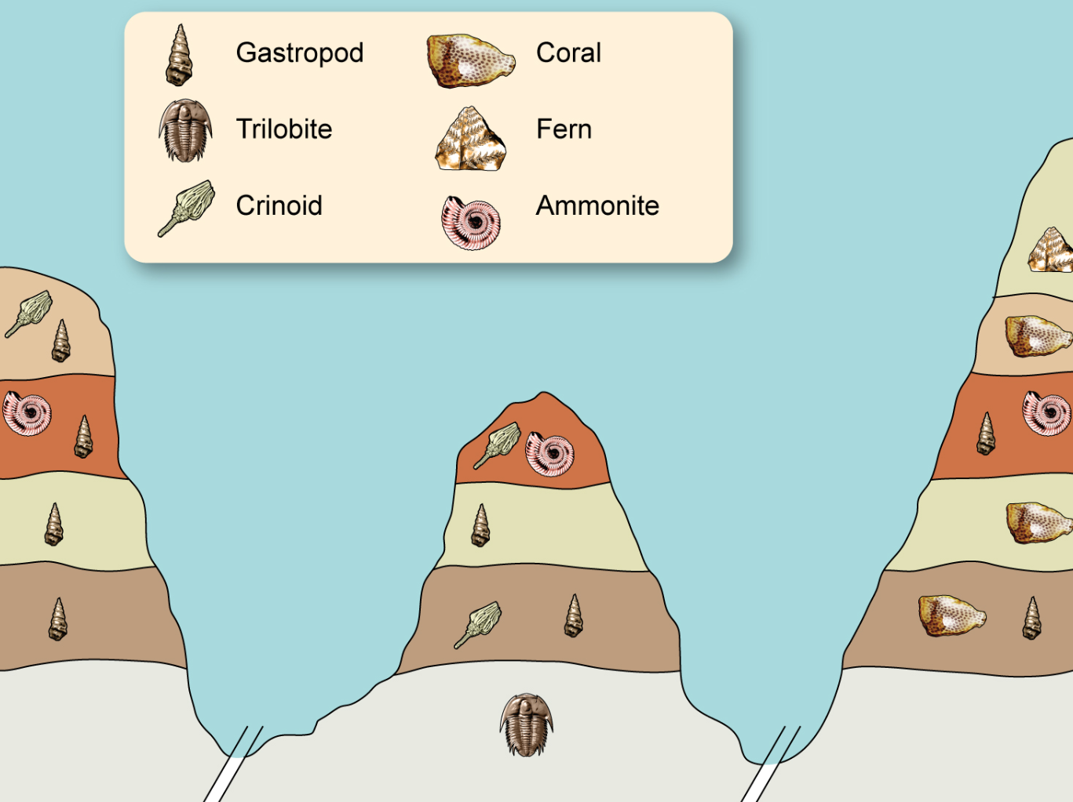

1. Which is the most recently evolved fossil out of the ammonite and crinoid? Provide a reason for your choice. (2 marks)

|  |  |
| --- | --- |
| **Description** | **Mark** |
| Ammonite | 1 |
| The ammonite appears in a more recent layer/ higher layer than the crinoid | 1 |
| **Total** | **2** |

1. Explain whether the gastropod would be a suitable organism to be used as an index fossil. (2 marks)

|  |  |
| --- | --- |
| **Description** | **Mark** |
| No | 1 |
| The gastropod appears in multiple strata/does not appear in a small (temporal) distribution | 1 |
| **Total** | **2** |

|  |  |
| --- | --- |
| **Question 34** | **(6 marks)** |

The diagram below shows the glands of the endocrine system.

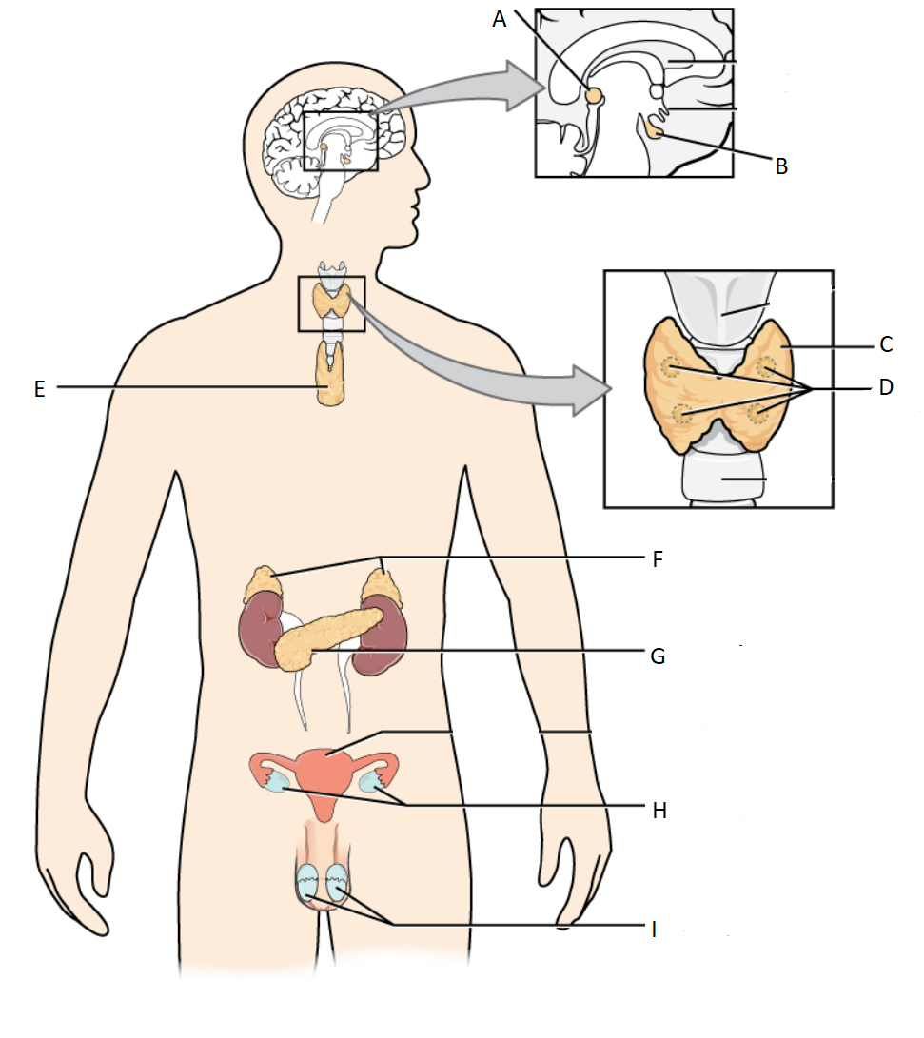

1. Name the endocrine organ at the location below: (1 mark)

|  |  |
| --- | --- |
| **Name** | **Mark** |
| C: Thyroid Gland | 1 |
| **Total** | **1** |

1. Provide an example of **one** hormone produced by the gland at location D. (1 mark)

|  |  |
| --- | --- |
| **Name** | **Mark** |
| Parathyroid Hormone | 1 |
| **Total** | **1** |

1. Cortisol and glucagon are both hormones that work to increase the levels of glucose in the blood. However, they differ in their mode of action. Cortisol is a lipid soluble hormone and glucagon is a water-soluble hormone. In the table below contrast the mode of action of these two hormones. (4 marks)

|  |  |
| --- | --- |
| **Contrast – Any 2 pairs of descriptions for 1 mark each** | **Mark** |
| Cortisol passes through the cell membrane  Glucagon binds to receptors on the membrane | 1 |
| 1 |
| Cortisol binds directly to the DNA/enters the nucleus  Glucagon has a secondary messenger | 1 |
| 1 |
| The effects of cortisol will last longer  The effect of glucagon will last for a much smaller amount of time | 1 |
| 1 |
| **Total** | **4** |
| **A labelled diagram that illustrates any of the above points can be used in students’ answers** |  |

|  |  |
| --- | --- |
| **Question 35** | **(11 marks)** |

Human mitochondrial DNA (mtDNA) contains 37 genes, all of which are involved in protein synthesis and cellular respiration. Comparison of mitochondrial DNA has allowed scientists to track differences in mtDNA sequences between human groups to show migration patterns around the world of our original ancestors. These differences in sequences are due to mutations.

* + - * 1. How is mitochondrial DNA inherited? Why does this feature make it suitable for tracking human movement over time? (3 marks)

|  |  |
| --- | --- |
| **Description** | **Mark** |
| Mitochondrial DNA is found in the cytoplasm on the egg/ovum and will be identical to your mothers mtDNA/ maternally inherited | 1 |
| All mutations will be passed on to all offspring | 1 |
| The gradual mutations will appear in different geographical areas at different times | 1 |
| **Total** | **3** |

Nuclear DNA is also prone to mutation. These mutations can be somatic or germline.

* + - * 1. Describe **one** possible consequence of acquiring a somatic mutation. (2 marks)

|  |  |
| --- | --- |
| **Description – Any 1 pair of description for 1 mark each** | **Mark** |
| Nothing/ no effect | 1-2 |
| the body’s immune system will destroy cells that contain (somatic) mutations/changes in DNA have no effect on protein synthesis |
| **OR** Cancer | 1-2 |
| The mutations will interrupt the cell cycle and the cell will replicate uncontrollably |
| **Total** | **2** |

Biochemical comparative protein studies can also provide evidence for evolution. Ubiquitous proteins such as cytochrome C, can be used for comparison of different species to determine how closely related to each other they are.

Parts (c) and (d) refer to the table below showing the differences in amino acids in the cytochrome C protein sequence between humans and other species of animals.

|  |  |
| --- | --- |
| Species compared with humans | Number of differences in amino acid sequence compared with human cytochrome C |
| Chimpanzee | 0 |
| Gorilla | 0 |
| Rhesus monkey | 1 |
| Rabbit | 9 |
| Tuna fish | 21 |

1. Describe how this data can provide evidence for evolution. (3 marks)

|  |  |
| --- | --- |
| **Description** | **Marks** |
| All living organisms have this ubiquitous protein | 1 |
| Some of the amino acids (37) are found at the same positions in every sequenced cytochrome C molecule | 1 |
| The more similarities between the number of the same amino acids the more recent the common ancestor/the less differences the further apart the ancestor | 1 |
| **Total** | **3** |

1. Draw a phylogenetic tree that depicts the relationships between the species in the table. Include *Homo sapiens* in you diagram. (3 marks)

Tuna Rabbit Rhesus Monkey Chimpanzee

Gorilla

Homo sapiens

|  |  |
| --- | --- |
| **Description** | **Marks** |
| Drawing of lines with relative distance is correct | 1 |
| Correct labelling for Tuna, Rabbit and Rhesus monkey | 1 |
| Correct labelling of great apes and human | 1 |
| **Total** | **3** |

|  |  |
| --- | --- |
| **Question 36** | **(17 marks)** |

Nerve impulse transmission is dependent on neurotransmitters such as acetylcholine allowing communication between neurons. Many factors can affect the effectiveness of this transmission.

1. Use an annotated diagram to describe, in as much detail as possible, how impulses are transmitted between neurons at the synapse. (6 marks)

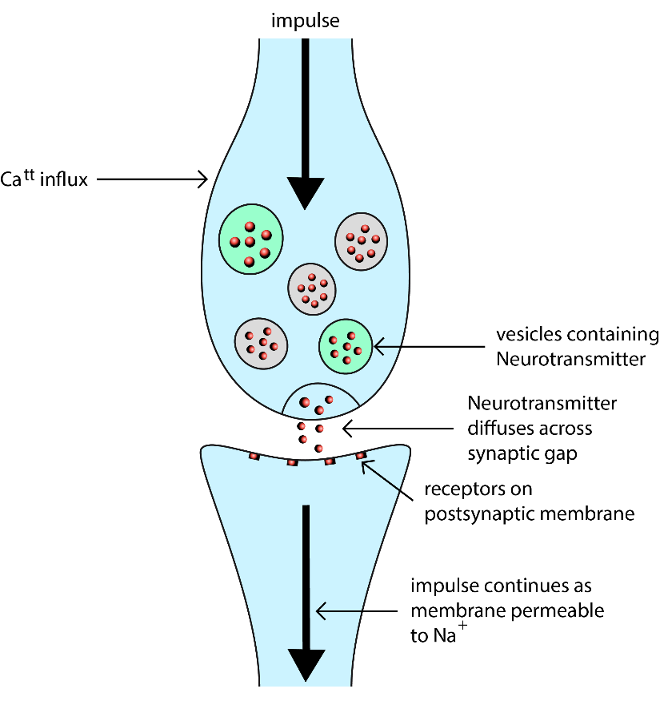

|  |  |
| --- | --- |
| **Description** | **Marks** |
| Label pre-synaptic and post-synapic membrane | 1 |
| Influx of calcium into axonal ending/synaptic knob as impulse arrives | 1 |
| Vesicles containing neurotransmitter fuse with surface of membrane (pre synaptic) | 1 |
| Neurotransmitter released via exocytosis and diffuses across synaptic gap/synapse | 1 |
| Binds to receptors on post synaptic membrane | 1 |
| Causes membrane to become permeable to sodium/depolarisation | 1 |
| **Total** | **6** |

Must have all detail labelled on diagram.

Julia was walking to her car in a shopping centre carpark. She was concentrating so much on her phone that she didn’t realise that she had walked into the middle of the road. A driver sounded their horn so that she would move out of the way. It startled her and she dropped the phone. Her heart started to race and she found that she was sweating.

1. Name the division of the nervous system that was causing Julia’s responses and describe **two** responses, other than those stated in the question, that she would have experienced. (3 marks)

|  |  |
| --- | --- |
| **Description** | **Marks** |
| Sympathetic nervous system | 1 |
| Any **two** of:   * Pupils dilate to enhance peripheral vision * Bronchioles/airways dilate to allow more air/oxygen to enter the lungs * Vasoconstriction in internal organs such as digestive system organs * Vasodilation of blood vessels in skeletal muscles * Decreases activity of digestive system * Increases glycogenolysis/release of glucose in the liver * Salivary secretions reduced * Relaxation of bladder muscles * Secretion of adrenaline by adrenal cortex | 1-2 |
| **Total** | **3** |

Multiple Sclerosis (MS) is considered an autoimmune disease. It causes demyelination (loss of myelin) within the brain and spinal cord.

1. Describe the role of myelin within the nervous system. (2 marks)

|  |  |
| --- | --- |
| **Description** | **Marks** |
| Increase the speed of nerve transmission | 1 |
| Allows nerve impulse to jump between nodes of Ranvier | 1 |
| **Total** | 2 |

1. Describe the effect MS may have on a person’s reaction time and explain why this may place a person at risk of injury. (4 marks)

|  |  |
| --- | --- |
| **Description** | **Marks** |
| Loss of myelin slows down speed of nerve impulse | 1 |
| Reaction time increases | 1 |
| Person takes longer to react | 1 |
| May cause more damage to body | 1 |
| **Total** | 4 |

(e) Explain what is meant by the term ‘autoimmune disease’. (2 marks)

|  |  |
| --- | --- |
| **explanation** | **Marks** |
| Immune system does not recognise ‘self’ antigens | 1 |
| Body’s own healthy tissue attacked | 1 |
| **Total** | 2 |

|  |  |
| --- | --- |
| **Question 37** | **(15 marks)** |

Diabetes mellitus is a serious chronic condition that has become one of the most prevalent lifestyle diseases in societies such as Australia and the USA, with approximately 280 Australians developing diabetes every day. (Source: Diabetes Australia; diabetesaustralia.com.au).

All types of diabetes are increasing in prevalence with Type 1 accounting for 10% and Type 2 for 85% of all diabetes cases.

1. Compare and contrast the onset, causes and symptoms of diabetes types 1 and 2. (8 marks)

|  |  |  |  |
| --- | --- | --- | --- |
| **Description** | | | **Marks** |
|  | **Type 1** | **Type 2** |  |
| **Onset** | * Usually before age 10 years/juvenile onset | * Usually at an older age/adult onset | 1-2 |
| **Causes** | * Autoimmune disorder affecting the beta cells in Islets of Langerhans | * Lifestyle disease eg obese, physically inactive | 1-2 |
| * No insulin produced | * Insulin produced but cells don’t respond to it | 1-2 |
| Symptoms - Any **two** of the following but must include at least **one** comparison | | | |
| **Symptoms** | * Excessive thirst and hunger | * Excessive thirst and hunger | 1-2 |
| * Large volumes of urine containing glucose/sugar | * Large volumes of urine containing glucose/sugar |
| * Fatigue | * Fatigue |
| * Weight loss | * Weight loss |
| **Total** | | | **8** |

1. Describe **three** treatments available for diabetes mellitus Type 2. (3 marks)

|  |  |
| --- | --- |
| **Description** | **Marks** |
| Any **three** of:   * Maintaining a healthy weight * Physical activity * Adopting a healthy diet low in fats, salt and high in fibre/complex carbohydrates * Medication that slows the absorption of glucose from the digestive system | 1-3 |
| **Total** | **3** |
| **Note:** Do not award marks for insulin. | |

Take the first three.

1. Explain how a diabetic would need to adjust their insulin dose if they are planning to do some strenuous exercise. (2 marks)

|  |  |
| --- | --- |
| **Description** | **Marks** |
| Need to decrease the dose of insulin | 1 |
| Exercise uses up more glucose/more glucose uptake by skeletal muscle cells | 1 |
| **Total** | **2** |

1. Explain why a diabetic would inject insulin prior to eating a meal. (2 marks)

|  |  |
| --- | --- |
| **Description** | **Marks** |
| Insulin is a hormone and takes time to have onset of action/slow onset of action | 1 |
| Once food is digested and glucose is released into the blood, insulin will have an effect | 1 |
| **Total** | **2** |

|  |  |
| --- | --- |
| **Question 38** | **(13 marks)** |

A researcher wanted to study the relationship between environmental temperature and the volume of sweat produced by young people in a controlled environment.

She recruited 20 healthy volunteers between the ages of 16-20 years. The volunteers were seated in a room initially at 22oC. The researcher gradually increased the temperature of the room and identified the volume of sweat produced by each volunteer in a 20 minute period at each temperature.

The average volume of sweat produced at each temperature is shown in the table below.

|  |  |
| --- | --- |
| **Temperature of the room (oC)** | **Volume of sweat (mL)** |
| 22 | 50 |
| 32 | 200 |
| 38 | 550 |
| 42 | 820 |
| 47 | 1270 |

1. Suggest an hypothesis for this experiment. (1 mark)

|  |  |
| --- | --- |
| **Description** | **Marks** |
| As room temperature increases the volume of sweat produced (by healthy young people) will increase | 1 |
| **Total** | **1** |

1. State the following variables; (2 marks)  
   * 1. Independent Variable:

|  |  |
| --- | --- |
| **State** | **Marks** |
| Temperature of the room (oC) | 1 |
| **Total** | **1** |

* + 1. Dependent Variable:

|  |  |
| --- | --- |
| **State** | **Marks** |
| Volume of sweat (mL) | 1 |
| **Total** | **1** |

Must have correct units for both.

1. Describe **three** variables, other than those mentioned above, that should have been controlled by the researcher. (3 marks)

|  |  |
| --- | --- |
| **Description** | **Marks** |
| Average weight/mass of volunteers | 1 |
| Volume of fluid intake prior to the experiment | 1 |
| Humidity in the room | 1 |
| **Total** | **3** |

1. Suggest **two** ways that this experiment could have been made more reliable. (2 marks)

|  |  |
| --- | --- |
| **Description** | **Marks** |
| Do more trials/repetition/replication | 1 |
| Have more volunteers/greater sample size | 1 |
| **Total** | **2** |

Sweating is a mechanism used by the body to maintain body temperature at a constant level.

1. If the researcher had also measured urine output, describe the trend in volume and concentration of urine produced as the room temperature increased. (2 marks)

|  |  |
| --- | --- |
| **Description** | **Marks** |
| Volume decrease | 1 |
| Concentration increase | 1 |
| **Total** | **2** |

**Question 39 (9 marks)**

A student is answering an exam question on the topic of osmoregulation.

The question asks, “*If osmotic pressure is low, describe the homeostatic mechanism that will cause the osmotic pressure to increase*”.

The student writes the following response, “*the hypothalamus will produce ADH inhibiting factor which will target the posterior pituitary gland and reduce the amount of ADH released*”.

(a) Explain why the student’s response is incorrect. (2 marks)

|  |  |
| --- | --- |
| **Explanation** | **Marks** |
| Hypothalamus produces ADH (not ADH inhibiting factor) | Any 2 |
| ADH is then stored in the PPG and released via nerve impulses |
| Inhibiting factors act on the APG not the PPG |
| **Total** | 2 |

(b) Describe how should the student have answered this question. (7 marks)

|  |  |
| --- | --- |
| **Suggest** | **Marks** |
| Water concentration in blood plasma increases/ osmotic pressure decreases | Any 7 |
| Osmoreceptors in the hypothalamus detect change in osmotic pressure |
| Hypothalamus stops/reduces nerve stimulus to PPG |
| PPG releases less ADH |
| Kidney tubule becomes less permeable |
| Less water reabsorbed |
| More water passed out in urine |
| Osmotic pressure increases |
| **Total** | 7 |

**End of Section Two**

|  |  |
| --- | --- |
| **Section Three: Extended answer** | **20% (40 Marks)** |

This section contains **three** questions. You must answer **two** questions. Write your answers on

the pages following Question 41.

Supplementary pages for planning/continuing your answers to questions are provided at the end

of this Question/Answer booklet. If you use these pages to continue an answer, indicate at the

original answer where the answer is continued, i.e. give the page number.

Suggested working time: 50 minutes.

_____________________________________________________________________________

Answer any **two** questions from Questions 40 to 42.

Indicate the questions you will answer by ticking the box next to the question. Write your

answers on the pages that follow.

**Question 40 (20 marks)**

Sam went on a hike in the bush, making sure he had a sufficient supply of water and food for the 6 hour journey. His blood pH must be maintained within narrow tolerance limits. However, if there is an increase in the carbon dioxide level in the blood, the pH decreases and respiratory acidosis could occur. This can lead to organ failure and can be life threatening.

1. Describe the homeostatic mechanism that would return the pH of the blood to within normal limits while Sam is hiking. In your response, explain why a person who is hyperventilating may be told to breathe into a paper bag. (8 marks)

|  |  |
| --- | --- |
| **Description** | **Marks** |
| Increase in carbon dioxide | Any 6 |
| Central chemoreceptors in the medulla oblongata detect this change |
| Peripheral chemoreceptors in aortic and carotid bodies detect change in pH |
| Stimulates respiratory centre in brain stem |
| Respiratory muscles contract |
| Breathing rate and depth increases |
| Excess carbon dioxide exhaled |
| CO2 levels in the blood decrease |
| **Total** |  |

|  |  |
| --- | --- |
| **Explanation** | **Marks** |
| Person will inhale excess carbon dioxide | 1 |
| Stimulating respiratory centre/medulla oblongata and increase breathing rate | 1 |
| **Total** | 2 |

The GPS system on his phone failed and, as a result, he lost his way back to his car. Sam realised that he would have to spend the night out in the open. The temperature dropped to 5oC overnight. Sam was found early the next morning safe and well, if not a little cold.

1. Name the receptors in Sam’s body that would recognise the change in external temperature. Describe what would have happened to his body temperature if it had rained during the night and he could not find shelter from the wind. (4 marks)

|  |  |
| --- | --- |
| **Name** | **Marks** |
| Peripheral thermoreceptors in skin | 1 |
| **Total** | **1** |

|  |  |
| --- | --- |
| **Description** | **Marks** |
| Sam would get wet/covered in water | 1 |
| the water would evaporate due to the wind having a cooling effect | 1 |
| his temperature would fall/drop/decrease/suffer hypothermia | 1 |
| **Total** | **3** |

Sam had only planned to be out in the wilderness for 6 hours and did not prepare any extra food in case of an emergency. Once he had eaten the food that he packed, he only had some water and chewing gum left. Sam did not eat for 10 hours prior to being rescued. The paramedics checked his blood glucose level which was at a relatively normal value of 4.5mmol/L.

1. Explain how Sam was able to maintain normal blood glucose levels despite not eating for 10 hours. (8 marks)

|  |  |
| --- | --- |
| **Description** | **Marks** |
| Stimulus | |
| decreased blood glucose levels | 1 |
| **Subtotal** | **1** |
| Receptor | |
| alpha cells in Islets of Langerhans (in pancreas) | 1 |
| **Subtotal** | **1** |
| Modulator | |
| alpha cells secrete glucagon | 1 |
| **Subtotal** | **1** |
| Effector | |
| liver andskeletal muscles | 1 |
| **Subtotal** | **1** |
| Response | |
| Glycogenolysis, conversion of glycogen into glucose | 1 |
| Gluconeogenesis, conversion of amino acids/fats into glucose | 1 |
| **Subtotal** | **2** |
| Feedback | |
| increase/maintain blood glucose levels | 1 |
| **Subtotal** | **1** |
| Adrenaline/cortisol | |
| cause gluconeogenesis/glycogenolysis | 1 |
| **Subtotal** | **1** |
| **Total** | **8** |

**Question 41 (20 marks)**

An evolutionary trend is a pattern of directional change that occurs in several species over a long period of time.

1. Referring specifically to prognathism, size of brain case compared to body size, and dentition, describe the changes seen in the following Hominid species.

* *Paranthropus robustus*
* *Homo habilis*
* *Homo erectus*  (9 marks)

|  |  |
| --- | --- |
| **Description** | **Mark** |
| Prognathism: | |
| *Paranthropus robustus* is the most prognathic | 1 |
| *Homo habilis* is more prognathic than erectus and less than robustus | 1 |
| *Homo erectus* is the least prognathic | 1 |
| Size of brain case: | |
| *Paranthropus robustus* has the smallest brain case | 1 |
| *Homo habilis* has a larger brain case than robustus and less than erectus/ 800cc | 1 |
| *Homo erectus* has the largest brain case/ 1000cc | 1 |
| Dentition: | |
| *Paranthropus robustus* U shaped jaw/ large molars | 1 |
| *Homo habilis* is more parabolic than robustus, less than erectus | 1 |
| *Homo erectus* is more parabolic/large canines | 1 |
| **Total** | **9** |

In 2015, palaeontologists uncovered fossilised remains of a new Hominid species *Homo naledi* in a complex cave network in South Africa. This species was identified to have legs and feet similar to *Homo sapiens* while having hands and a pelvis similar to *Australopithicus afarensis.* The *Homo naledi* specimens were dated as being between 36000 and 45000 years old.

1. Describe the features you would expect to see in the legs, feet, hands and pelvis of *Homo naledi*. (8 marks)

|  |  |
| --- | --- |
| **Description** | **Mark** |
| Legs: Any **two** | |
| Broad epiphysis/large lateral condyle/outer portion of knee | 1-2 |
| Comparatively long femur |
| Large head and long neck of femur |
| Feet: Any **two** | |
| Transverse arch | 1-2 |
| Longitudinal arch |
| Large calcaneus |
| Large big toe |
| Parallel big toe |
| Hands: Any **two** | |
| Shorter thumb and long curved fingers | 1-2 |
| Less opposability |
| Power grip but no/limited/some precision grip |
| Pelvis: | |
| Shorter | 1 |
| Broader | 1 |
| **Total** | **8** |

1. Name the dating method that was used to assign an age to the *Homo naledi* specimens and explain why this method was used. (3 marks)

|  |  |
| --- | --- |
| **Description** | **Mark** |
| Carbon 14 dating | 1 |
| Carbon 14 is up to 60000 years old which is the age range of the specimen | 1 |
| Carbon 14 is used on organic specimens/need more than 3 grams | 1 |
| **Total** | **3** |

**Question 42 (20 marks)**

The remains of two species of hominoids were found within a five kilometre range of each other and were, for many years, thought to be of the same species. With the evolution of biotechnology techniques, scientists decided to check more thoroughly as there were some differences observed that were originally explained as general variation within the species.

1. Explain how mutations cause variation between members of the same species, and why these mutations can be advantageous. (5 marks)

|  |  |
| --- | --- |
| **Description** | **Marks** |
| Any **three** of:   * Mutations that are permanent changes in DNA to produce new characteristics * If the mutation occurs in a gamete/egg or sperm it can be passed on from generation to generation * Gene mutations can cause changes to traits normally produced by that gene * These changes can have significant effects on the characteristics of the organism | 1-3 |
| **Subtotal** | **3** |
| Any **two** of:   * Changed traits allow the organism to be better suited to their environmental selection pressures * This contributes to better survival * Advantageous traits can be passed on through the generations | 1-2 |
| **Subtotal** | **2** |
| **Total** | **5** |

1. Name and describe the techniques that scientists would have used to determine whether or not the hominoids were of the same species given that very small amounts of DNA were able to be extracted from the remnants found. (10 marks)

|  |  |
| --- | --- |
| **Description** | **Marks** |
| Technique | |
| Polymerase chain reaction (PCR) | 1 |
| Description | |
| Any **four** of:   * DNA is denatured to separate the strands * Primers are added * Annealing where the solution is cooled allowing primers to bond to DNA strands * Extension as nucleotides attach to DNA strands | 1-4 |
| **Subtotal** | **5** |
| Technique | |
| Gel electrophoresis (must name the technique) | 1 |
| Description | |
| Any **four** of:   * DNA pieces/lengths are placed in gel (in wells) * Electric current is passed through the gel * Negatively charged DNA moves through the gel to the positive electrode * Smaller pieces of DNA move faster than Large pieces * Banding pattern results | 1-4 |
| **Subtotal** | **5** |
| **Total** | **10** |

1. Outline the process of speciation. (5 marks)

|  |  |
| --- | --- |
| **Outline** | **Marks** |
| Variation within a species | Any 5 |
| A barrier divides the populations |
| Isolation of the members of the species |
| No interbreeding occurs between the separated population |
| Each population has a separate gene pool |
| Different selection pressures act on the two populations |
| Change in gene frequencies of each gene pool |
| Changes may be great enough to prevent production of fertile offspring |
|  |
| **Total** | 5 |